Software Requirements Specification

Smart Attendance System
Version 1.0
Arbab Ahmed|
EP-1550010
Department of Computer Science, University of Karachi
5/March/2018
Table of Contents
Table of Contents ii
1. Introduction 1
1.1 Purpose 1
1.2 Document Conventions 1
1.3 Intended Audience and Reading Suggestions 1
1.4 Product Scope 1
1.5 References 1
2. Overall Description 2
2.1 Product Perspective 2
2.2 Product Functions 2
2.3 User Classes and Characteristics 2
2.4 Operating Environment 2
2.5 Design and Implementation Constraints 2
2.6 Assumptions and Dependencies 3
3. External Interface Requirements 3
3.1 User Interfaces 3
3.2 Hardware Interfaces 3
3.3 Software Interfaces 3
3.4 Communications Interfaces 3
4. System Features 4
4.1 System Feature 1 4
4.2 System Feature 2 (and so on) 4
5. Functional Requirements 4
6. Other Nonfunctional Requirements 4
5.1 Performance Requirements 4
5.2 Safety Requirements 5
5.3 Security Requirements 5
5.4 Software Quality Attributes 5
5.5 Business Rules 5
7. Other Requirements 5
Appendix A: Glossary 5
Appendix B: Analysis Models 5
Appendix C: To Be Determined List 6

Introduction

Purpose
This document is intended to provide a detailed description of the project Smart Attendance System. It will illustrate the purpose, interfaces, features and other requirements for the software as well as the constraints of the system. This document is intended to propose to customer and development team as a reference guide for development.

Intended Audience and Reading Suggestions
This document is made to be read by customer for the software, development team and marketing staff.

Product Scope
The “Smart Attendance System” is a GPS-based mobile application which is used by the organizations where their offices and sites are not in their reached directly to look after.

Office/Sites owners can register their sites/offices by adding LATTITUDE and LONGITUDE of the site location and set the radius around its latitude and longitude (e.g. 2KM) along with its name. As the employee (added by the owner) enters into the radius (set by the owner) the attendance will automatically mark and as the employee leaves that particular area it has been automatically marked as checkout with respect to time.

Furthermore, the software needs both Internet and GPS connection to mark the attendance and checkout. All system information is maintained in a database, which is located on a web-server. The software also interacts with the GPS-Navigator software which is required to be an already installed application on the user’s mobile phone.

References
-Business Requirement Document
-Use case diagram

Terms and their definition

TERM | DEFINITION
User | Someone who interacts with the mobile phone application
Admin/Owner | App administration who have specific permissions to modify the data
GPS | Global Positioning System

Overall Description

Product Perspective
This system will consist of two broad parts:
One for users and for owner. The owners part of application will be used to add new geo-fences, view added geo-fences, update geo-fences, delete geo-fences, also add users, update users, and delete users while the user application will be used for checking logs for their attendance and checkouts times with different filters. The attendance and checkout will do automatically.

The system will need to communicate to a GPS application within the mobile phone, which in turn communicates with a physical GPS device to find the location of the user. The GPS will provide the mobile application with locations (latitude and longitude) to mark the attendance and do checkouts automatically.

A database will be used. As the user/employee into the radius assigned by the owner the attendance will mark and update the database and it happens the same on checkout.

Product Functions
Feature | Description
Add geo-fence | This process will allow the owner to add geo-fence with longitude and latitude along with its radius and name.
Add User | This process will allow the owner to add user.
View Logs | This feature enables the user/employee so that they can view their attendance and checkout logs.
Automatic Attendance | This enables the device to automatically mark the attendance when the user/employee enters in the radius assigned by the admin.
Automatic Checkout | This enables the device to automatically mark the checkout with time when the user/employee exit from the radius assigned by the admin.
Claim logs | This feature enables the employee to claim their logs if the feel any sort of error in there.

User Classes and Characteristics

There are two types of users that interact with the system:
* The mobile application users can only use the application to mark their attendance and checkouts and can only see their logs

* The owner will use the mobile application to maintain the geo-fences and the users.

Operating Environment

Application Server:
All the data of the system will be stored on a web-server.

Client System
An android phone with GPS enabled services.

Design and Implementation Constraints
The mobile application is constrained by the system interface to the GPS navigation system within the mobile phone. Since there are multiple system and multiple GPS manufacturers, the interface will most likely not be the same for every one of them. Also, there may be a difference between what navigation features each of them provide.

The Internet connection is also a constraint for the application. Since the application fetches data from the database over the Internet, it is crucial that there is an Internet connection for the application to function.

Assumptions and Dependencies
One assumption about the product is that it will always be used on mobile phones that have enough performance. If the phone does not have enough hardware resources available for the application, for example the users might have allocated them with other applications, there may be scenarios where the application does not work as intended or even at all.

Another assumption is that the GPS components in all phones work in the same way. If the phones have different interfaces to the GPS, the application need to be specifically adjusted to each interface would mean the integration with the GPS would have different requirements than what is stated in this specification.

External Interface Requirements

User Interface

Main Screen

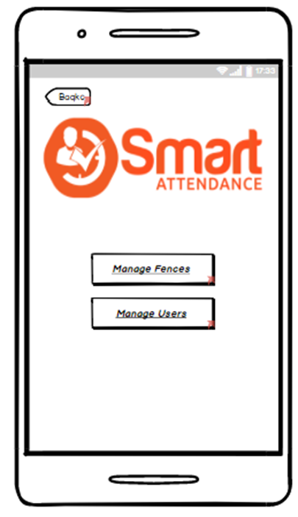

Home Screen

Fences

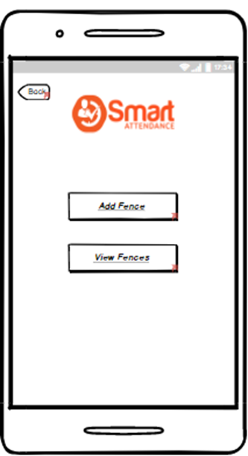

Add Fences

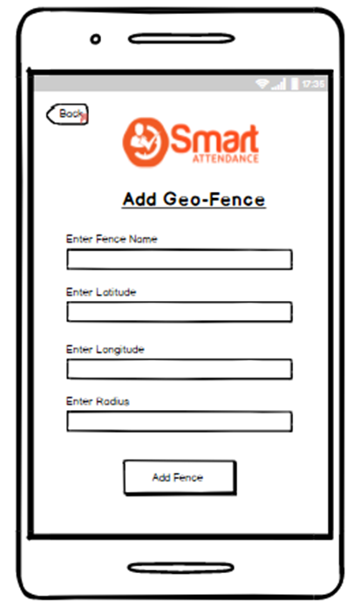

View Fences

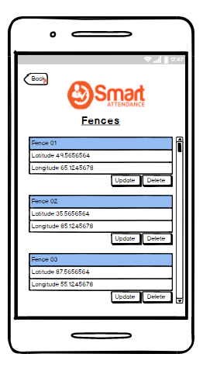

Add User

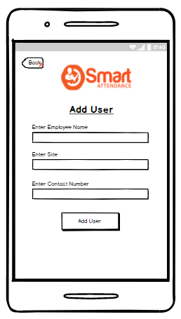

View Users

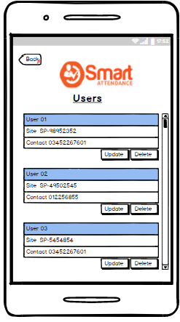

Claim Logs

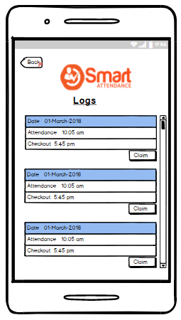

Hardware Interfaces
Since neither the mobile application nor the web server has any designated hardware, it does not have any direct hardware interfaces. The physical GPS is managed by the GPS application in the mobile phone and the hardware connection to the database server is managed by the underlying operating system on the mobile phone and the web server.

Software Interfaces
The mobile application communicates with the GPS application in order to get geographical information about where the user is located. The communication between the database and the application of admin consists of operation concerning both reading and modifying the data, while the communication between the database and the mobile application consists of only reading operations.

Communications Interfaces
The communication between the different parts of the system is important since they depend on each other. However, in what way the communication is achieved is not important for the system and is therefore handled by the underlying operating systems for both the mobile applications.

System Features
This system elaborates major features of the product along with its functional requirement

Login Admin
4.1.1 Description and Priority
The process will provide the Admin ability to log-in via their profiles in system database.
Priority: high
4.1.3 Functional Requirements
FR-1: System shall provide forgot password module to retrieve user password

Add Geo-Fence
4.1.1 Description and Priority
The process will provide the admin ability to add new geo-fence location in the system database.

Priority: high
4.1.3 Functional Requirements
N/A

Add User
4.1.1 Description and Priority
The process will provide the admin to add new user/employee in the system database.
Priority: high
4.1.3 Functional Requirements
N/A

Automatic Attendance
4.1.1 Description and Priority
The process will provide the user ability to mark their attendance automatically

Priority: high
4.1.3 Functional Requirements
N/A

Functional Requirements

Update and release
ID: FR2
TITLE: Download and notify users of new releases
DESC: When a new/updated version or release of the application is released, the user should check for these manually.

User login
ID: FR4
TITLE: Admin log-in - Mobile application
DESC: Given that a user has registered, then the Admin should be able to log in to the mobile application. The log-in information will be stored on the phone and in the future the user should be logged in automatically.

Automatic Attendance
ID: FR6 T
ITLE: Automatic attendance
DESC: Given that a user is logged in to the mobile application, then the first page that is shown should be the Automatic attendance page.

Other Nonfunctional Requirements

Performance Requirements
5.1.1 View logs in list view
ID: QR3
TITLE: View logs in list view
DESC: The results displayed in the list view should be user friendly and easy to understand.

5.1.2 Response Time

ID: QR6
METER: Measurements obtained from 1000 searches during testing.
MUST: No more than 2 seconds 100% of the time.
WISH: No more than 1 second 100% of the time.

Safety Requirements
N/A

Security Requirements
5.3.1 Communication Security

ID: QR12
TAG: Communication Security
SCALE: The messages should be encrypted for log-in communications, so others cannot get user-name and password from those messages.
METER: Attempts to get user-name and password through obtained messages on 1000 log-in session during testing.
MUST: 100% of the Communication Messages in the communication of a log-in session should be encrypted. Communication Messages:

Software Quality Attributes
- Support more than 1000 concurrent users
- User interface non-functional requirements

Other Requirements
<N/A>
Appendix A: Glossary
<Define all the terms necessary to properly interpret the SRS, including acronyms and abbreviations. You may wish to build a separate glossary that spans multiple projects or the entire organization, and just include terms specific to a single project in each SRS.>
Appendix B: Analysis Models
<Optionally, include any pertinent analysis models, such as data flow diagrams, class diagrams, state-transition diagrams, or entity-relationship diagrams.>
Appendix C: To Be Determined List
<Collect a numbered list of the TBD (to be determined) references that remain in the SRS so they can be tracked to closure.>

